**Reflection article**

**A Reflection on a Didactical Design for Training Teachers in the Incorporation of Technology into the English Classroom**

**Reflexión sobre un Diseño Didáctico para Entrenamiento Docente en la Incorporación de la Tecnología a la Clase de Inglés**

**Gonzalo Camacho-Vásquez[1], Elena María Díaz-Pareja[2], Juana María Ortega-Tudela[3]**

**Para citar este artículo:** Camacho-Vásquez G., Díaz-Pareja E. y Ortega-Tudela J. (2023). A web-based Learning Didactical Design for Training Teachers in the Incorporation of Technology into the English Classroom. Praxis, 19(2),xx-xx. <https://doi.org/10.21676/23897856.4979>

**ABSTRACT**

During the pandemic, emergency remote teaching (ERT) has shown the urgent need to train teachers in integrating technology in the classroom. This need becomes a requirement in English language teaching because using digital tools enables the development of cultural and intercultural competence. The literature review demonstrates that there are models that guide the integration of information technologies (ICT) in education in general. Still, a didactic design with procedures to train English teachers was not found. This article aims to describe and theoretically support a Web-based Didactic Design to train English teachers in using ICT in ELT. The Design is part of the Development and Implementation phases of a study that seeks to establish its effects on Teacher Digital Competence using the DigCompEdu framework. The construction of the Didactic Design is based on the Theory of Research through Design and the ADDIE Model of Instructional Design. The literature review establishes guidelines for formulating the Design and the limitations to be considered.

**Keywords:** ICT, ELT Didactics, Didactical Design, Innovation, Teachers’ Professional Development.

**RESUMEN**

La enseñanza remota por emergencia (ERE) durante pandemia han demostrado la urgente necesidad de capacitar a los docentes en la incorporación tecnología al aula de clase. En la enseñanza del inglés, esta necesidad se convierte en una exigencia debido a que el uso de herramientas digitales posibilita el desarrollo de la competencia cultural e intercultural. La revisión literaria demuestra que existen modelos que guían la integración de las tecnologías de información (TIC) en educación en general, pero no se encontró un diseño didáctico con procedimientos para capacitar docentes de inglés. El presente artículo busca describir y sustentar teóricamente un Diseño Didáctico basado en la Web para entrenar docentes de inglés en el uso de las TIC en ELT. El Diseño es parte de las fases de Desarrollo e Implementación de un estudio que persigue establecer sus efectos en la Competencia Digital Docente utilizando el marco del DigCompEdu. La construcción del Diseño Didáctico se fundamenta en la teoría de la Investigación a través del Diseño y el Modelo ADDIE de Diseño Instruccional. La revisión bibliográfica y los resultados del cuestionario de Análisis establecen lineamientos para la formulación del Diseño y limitaciones a tener en cuenta.

**Palabras Claves**: ICT, Didáctica del ELT, Diseño Didáctico, Desarrollo Profesional Docente.

**INTRODUCTION**

Training English Teachers to incorporate ICTs into ELT is more than a need. It has been proved that Web-based technologies benefit language acquisition (Pikhart, 2018; Kara, 2021; Cong-Lem, 2018). There are multiple pedagogical models or learning designs that seek to show a path in the integration of technology into education. The TPACK Model Mishra and Koehler (2006), the SAMR Model Puentedura (2014) and the SOSE Model Salem (2019) present solid theoretical foundations and attempts to show procedures for their implementation. A second group of models raises awareness on the importance of considering other aspects like elaboration of knowledge, use of multimedia, and teachers’ background and beliefs.

**Pedagogical models and learning designs**

The TPACK Model (Technological Pedagogical Content Knowledge) proposed by Mishra and Koehler (2006) is a common denominator in creating other new proposals. The model conceives teachers’ professional development in technology from three types of knowledge that need to be integrated: Pedagogical Knowledge, Technological Knowledge, and Content Knowledge. Pedagogical knowledge is the different methodologies or teaching approaches applied in the classroom. Technological knowledge is the technological resources and tools used to teach the content, and the content is the specific subject area or discipline. When these three types of knowledge are combined, they become Technological Pedagogical Content Knowledge presented in Technological Pedagogical Knowledge, Technological Content Knowledge, and Pedagogical Content Knowledge.

Camacho-Vásquez *et al.,* (2023) conducted a systematic literature review about pedagogical models and designs, whose results are summarized in Table 1. In short, these authors found that most of the pedagogical mode focused mainly on technological knowledge because it is taken for granted that educators already manage the content and the pedagogical knowledge; however, this latter becomes an obstacle when teachers intend to move the same didactical strategies, they use in the physical classroom to a virtual learning environment. That is where the SAMR-TPACK Model, proposed by Puentedura (2014) gains validity.

**Table 1.** Systematic Review of the Literature about Pedagogical Models and Didactic Designs

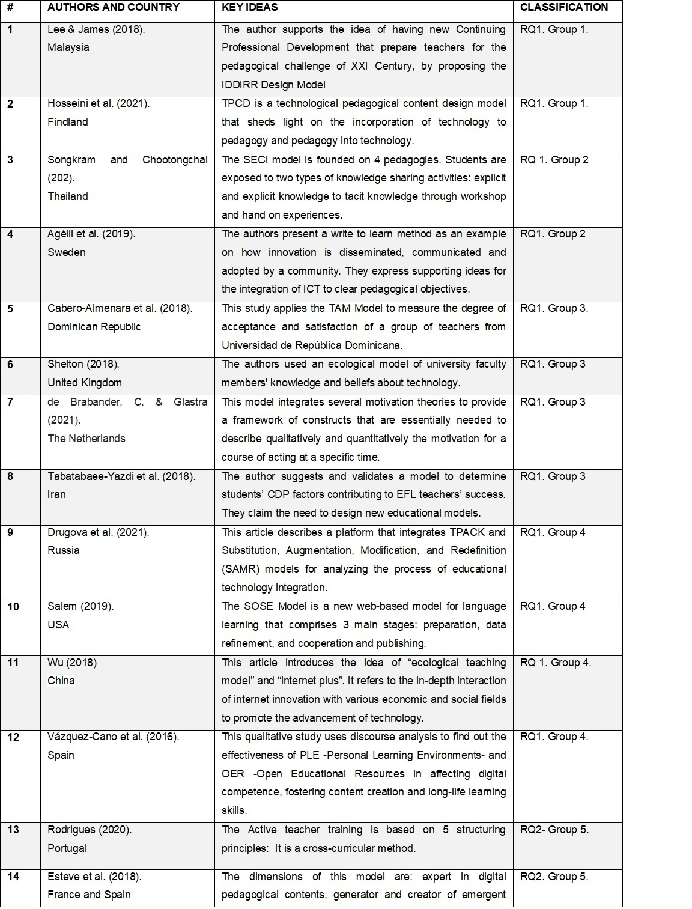

**Source:** Camacho-Vásquez *et al.,* (2023)

Puentedura’s model organizes classroom technology implementation in four stages. Substitution is the most superficial stage, where EdTech (Educational Technology) is used as a substitute for traditional classroom practices. One example of substitution could be when the blackboard or the whiteboard in the classroom is changed by a Google Jam board, where students can write for the whole group and work collaboratively when visiting other classmates' boards and adding comments or suggesting ideas. It is important not to substitute only because of the fashion of technology but because the new source adds something else to the learning process (Puentedura, 2013). This is what augmentation deals with. Having students inquire on the World Wide Web about concepts of a particular subject or project theme, instead of the mere teachers’ input, train them in using self-regulated learning strategies, allow them to grow in autonomy, and foster lifelong learning strategies. In the Modification stage, technology is used to design interactive and dynamic tasks beyond the limits of the physical classroom. Introducing changes to the traditional pen and paper activity called "Find Someone Who" enables students to ask questions to their classmates and use WhatsApp to interact with students worldwide by voice or text messages according to the communicative skills the English teachers intend them to practice. Finally, in the Redefinition stage, teachers design new tasks introducing new learning chances. Technology is integrated meaningfully through engaging activities that connect students' senses and train them to use soft skills when exposing them to multiple cultures, literacies, and multi-modal resources.

One of the most exciting proposals regarding its theoretical foundation and the response to learning in the XXI Century is the SOSE Model proposed by Salem (2019). It is a new web-based model comprising three main stages: preparation, data refinement, cooperation, and publishing. It is “an internet-based environment in which students investigate a topic, try to answer some set questions, or solve a problem in collaboration with their peers” (Salem, 2019, p. 2505). Pupils are actively involved in their learning, take risks, learn from their errors, and assume responsibility for their learning. Another important point related to SOSE is that its main components cope with the requirements for developing hard skills (i.e., cognitive skills), soft skills (i.e., higher-order thinking skills and twenty-first Century Skills,) and hot skills (i.e., collaboration) in addition to its positive impact on developing academic achievement and language skills. The model is founded on well-known theories and approaches to learning like Web-Based Learning, Constructivism, Scaffolding strategies, Project-Based Learning, Inquiry-Based Learning, and Discovery Learning. Unfortunately, there is not much theory that describes the method in depth. The steps established in the learning trajectory need to be revised to demonstrate the application of the founded theories that provoke its emergence.

The SECI Model Nonaka and Takeuchi (1995) seeks to introduce innovation and creativity through solid theoretical foundations that provoke learning through the incentive of explicit knowledge and tacit knowledge, while the incorporation of PLE (Personal Learning Environments) in OER (Open Educational Resources) merge as a wonderful possibility to administer self-directed learning processes, organize digital tools for ELT and share personal production according to proposed Learning Outcomes. Figure 1 shows an example of a PLE for the Diplomado Course that is part of the implementation stage of this methodological proposal. The Model of Holistic Competence for the Digital Word Esteve *et al.,* (2018) is addressed to primary education teachers and intends to surpass the definition of Digital Teacher Competence by assuming the concept not from an instrumental vision of technology but responding to an integral teacher. Regarding the Teachers' Digital Competence, the authors say that educators need to be able to use ICT to enrich classical didactic models that respond to students’ learning needs. They also insist on using Design-based Research (DBR) or Educational Design Research (EDR) to assume research as a teaching practice.

**Figure 1**.Symbaloo used as a PLE

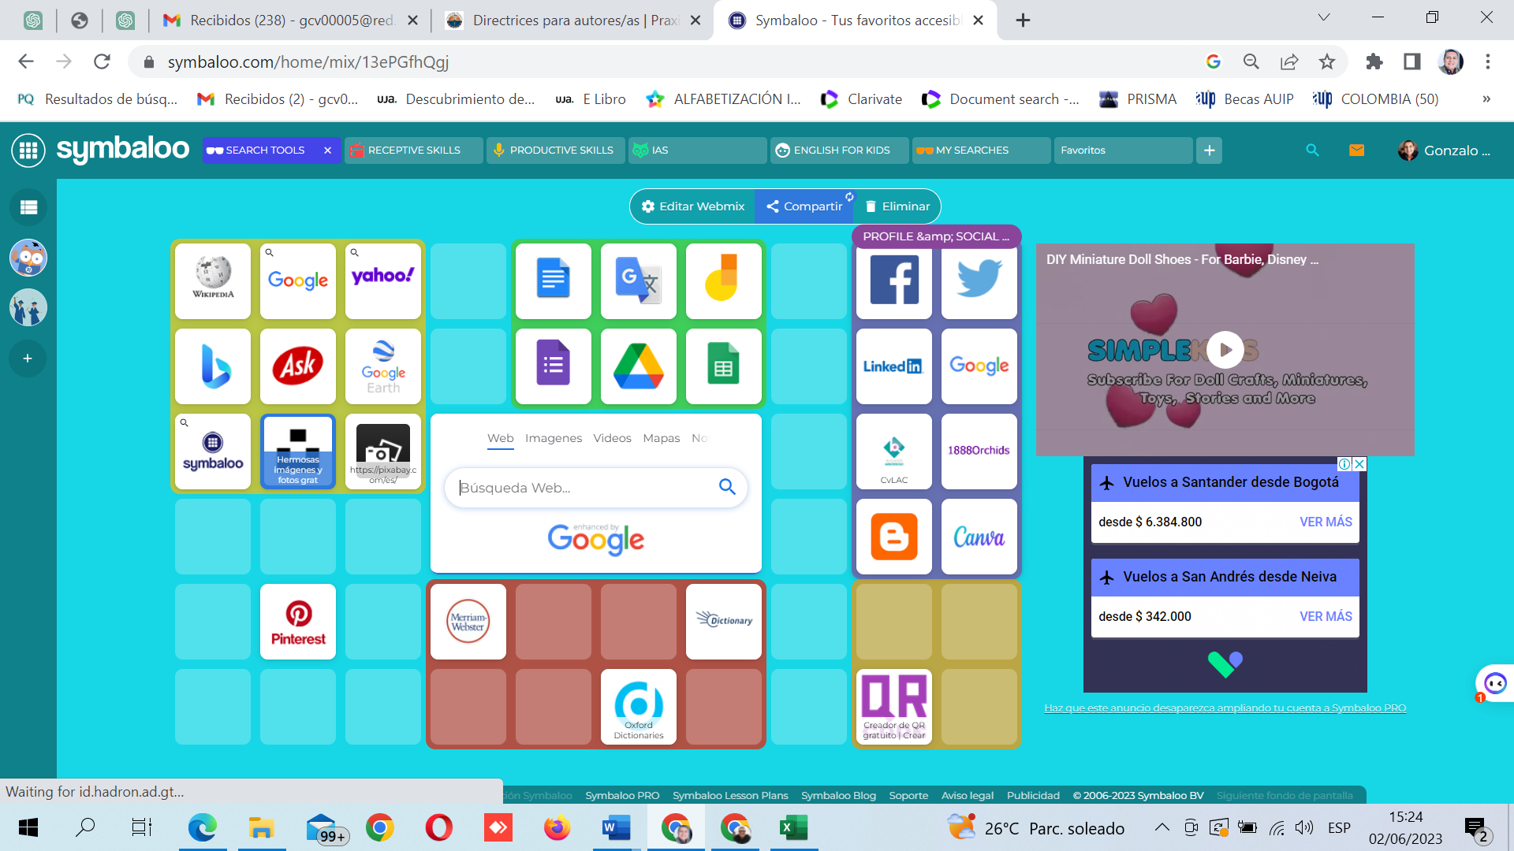

**Source**: Own elaboration using Symbaloo

The literature review allows us to conclude that a didactical design to training teachers in the use of ICT to ELT needs to have the following components: solid theoretical foundations that define its procedures as the SOSE Model shows, awareness of the way teachers integrate technology into their practice using the SAMR Model as a reference, knowledge processing from individual to group interactions and from the elaboration of explicit knowledge to tacit knowledge as recommended by the SECI Model, use of PLEs (Personal Learning Environments) to achieve the purposes mentioned above, use of multimedia web-available resources, take into account teachers' background as the Holistic Model for the Digital World, and consider teachers’ beliefs and contextual issues as the Ecological Model recommends.

**The objective of the reflection**

The present study pursues the following:

To formulate a Web-Based Learning Didactical Design for training teachers in developing Digital Competence applied to English Language Teaching based on the literature review results and incorporation of existing educational theories.

**DEVELOPMENT OF THE REFLECTION**

The methodology used to conceive the WBLDD is founded on a branch of research that integrates arts and science into a proposal called Research Through Design (RtD), where designers create new products by experimenting with new materials and processes (Godin & Zahedi, 2014). Dohn and Hansen (2014) conceive the Design as giving form to something, and in education, it shapes a focus and critical points for teaching and learning as a process to reach specific learning outcomes. There is an argument concerning the nature of design and design research. Borgdorff (2006) and Krippendorff (2007) ask if Design is more related to arts or science. The first author conceives the concept of Design in the idea of artifacts, proposals, and conjectures. As a result, Design in research is related to something new that may introduce a difference to what already exists. This change may occur in education in a new way of conceiving the curriculum or classroom didactics. In the latter aspect, researchers may think of new forms of conceiving content, organizing learning trajectories, or assessment strategies. Technology becomes an appropriate field to introduce innovation in the classroom by inventing new apps, new video games, or new gadgets (like Symbaloo) for self-regulated incentive learning. Remote Learning during Covid-19 made teachers aware of the richness of technology when it is integrated to education. Giraldo Cadavid and Fernández García (2023) demonstrated how the implementation of short video creation in science class in a rural school during Pandemic times responded to students’ learning rhythms, enhanced teachers’ digital competence, and enable the development students’ oral skills.

The ADDIE Model (Branch, 2009) is applied in this project as an instructional design framework (Analyze, Design, Develop, Implement, and Evaluate) in the analysis of needs regarding Teachers’ Digital Competence and theoretical background about Web-Based Learning models, in the Design of the WBLDD, in the development of a Diplomado Course to implement the didactical proposal, and in the evaluation of the process. The estimated population to apply the WBLDD and assess its effectiveness consist of a group of B.A. in English Teaching pre-service teachers, a group of university teachers, and a group of school teachers.

**THEME DEVELOPMENT**

**Definition of the Web-based Didactical Design**

The Web-based Didactical Design is an eight-step methodological proposal for teachers' training in incorporating ICTs to ELT with online and offline moments, founded on solid pedagogical theories and approaches and intending to develop TDC.

**Figure 2**. Web-based Learning Didactical Design

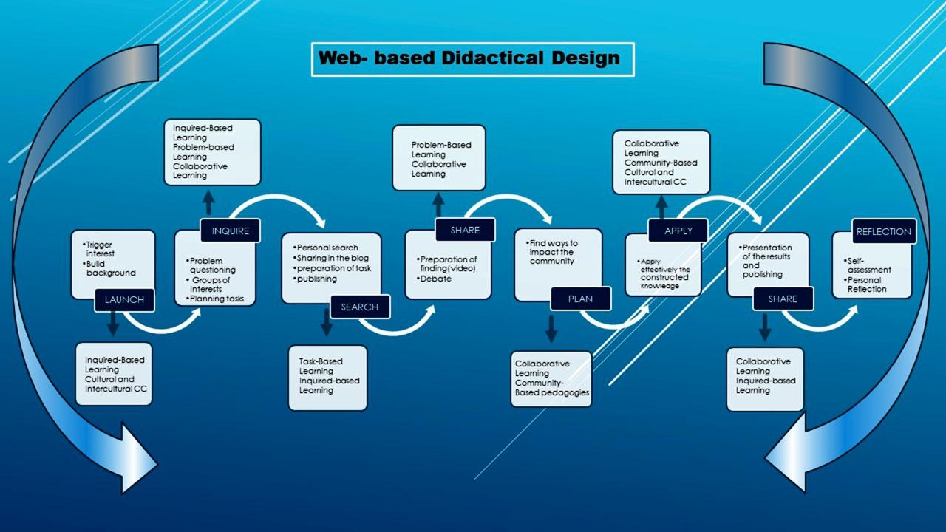

**Source**: Own elaboration of the author

**Learning Aims of the web-based didactical design**

The proposed Design intends primarily to develop teachers’ digital competence in the incorporation of ICT tools to ELT utilizing a process of adoption, adaptation, appropriation, and innovation of technology; secondly, it pursues to train language teachers on the adaptation of ELT didactics to technology-mediated environments as a way to foster collaborative and autonomous learning skills in their students; thirdly, the Design intends to boost teachers’ critical thinking in language teaching via problem-based learning and inquiry-based learning strategies, which may trigger their capacities of relating constructed knowledge to local contexts via community-based pedagogies’ strategies. Thirdly, it intends to awaken teachers' interest in using web-based learning materials as an alternative to developing cultural and intercultural competence.

**Theoretical foundations**

Although the boundaries of the theoretical foundations are not seen in a learning model, this section is devoted to defining each of these theories and how they are present in the different moments of the learning trajectory. They should not be conceived as separate components of the model. An activity, a strategy, a technique, or a tactic in the didactical Design may be based on one or more of these epistemological bases.

**Web-based learning (WBL)**

Zheng (2008) defines Web-based learning as “the type of learning that uses the internet as an instructional delivery tool to carry out various learning activities” (p. 752). WBL may be pure online learning, which has no face-to-face mediation between teachers and students, or hybrid, in which the instructors meet students half of the time online and half the time in the classroom. In this case, the WBL Didactical Design is pure online learning with online gathering activities and offline individual and group tasks. Kalaian (2017) says that WBL is “an innovative student-centered instructional method for teaching/learning of the digital course content delivered in the distance via the internet and mediated by computer communications and web-based technologies” (p. 23). This author mentions that WBL is also called e-learning, Cyberlearning, or online learning.

The WBL Didactical Design is implemented by employing a 200-hour online course. It plans to fulfill the different learning conditions and learning needs of the groups of teachers in the target population. It allows the inclusion of not only teachers that live in the state's capital city but also educators from the five zones of the region and from all over the country.

**Constructivism**

In the history of pedagogy, Constructivism is recognized as the theory that marked a shift from the behavioral perspective, which assumes that learners are empty minds that need to be filled with the knowledge that teachers and books own, to a learner-centered conception where knowledge does not exist, but is constructed through active interaction with the environment involving senses to gain experience (Suhendi, 2018). This idea of learning is rooted in Piaget's and Vygotsky's theories. Piaget introduced the idea that learning happens when individuals interact with their real-world gaining experiences as new knowledge fits their cognitive capacities. In his Cultural Historical Activity Theory (CHAT Theory), Vygotsky believes in a more social-focused process where learning results from the active interaction of individuals with their community and culture. Altogether, in language learning, for example, teachers need to consider the mental capacities of the learners, their interests and likes, and expose them to meaningful learning settings. For instance, to develop oral skills and acquire food-related vocabulary, teachers may change the classroom into a restaurant where students order meals from a menu and interact using realia. In developing the WBL Didactical Design, authentic learning in meaningful contexts is prioritized. Teachers in training not only appropriate the technological or pedagogical knowledge but also decide what to learn depending on their classroom needs. More importantly than the final product, the awareness of the learning process through personal reflection is emphasized, and learning occurs by applying the constructed knowledge to solve didactical problems of language acquisition in their classrooms.

**Inquiry-based learning (IBL)**

Inquiry-based Learning (IBL) is often associated with Problem-based Learning or Discovery Learning Acar and Tuncdogan (2018). It may be defined as an educational strategy mainly used in science to guide students to discover learning through constant questioning and formulation of hypotheses tested by conducting experiments or making observations Pedaste *et al.,* (2015). Three types of inquiries exist: Open vs. Closed Inquiries, Discovery-Focused vs. Information-Focused Inquiries, and Individual vs. Team Inquiries.

In an open inquiry, students identify the problem and the ways to solve it, while in a closed inquiry, the teacher introduces the problem and establishes the route to be solved. In a discovery-focused inquiry, the aim is to create innovation by designing something original, like a product or academic knowledge; in an information-focused inquiry, the objective is to explore and acquire existing knowledge, for instance, a literature review. Finally, an IBL could be used for individual inquiry or team-based learning.

In inquiring, formulating the questions plays a fundamental role in the learning sequence. Camacho (2017) carried out a research study to improve the construction of research questions by linking Inquiry as Orientation for Learning with the Logic of Sense (Deleuze, 2005). As a result, he came up with a question-formulation design that conceives three moments: the Series of Ideas, the Series of Questions, and the Series of Happenings.

**Figure 3.** The Problem for the Logic of Sense

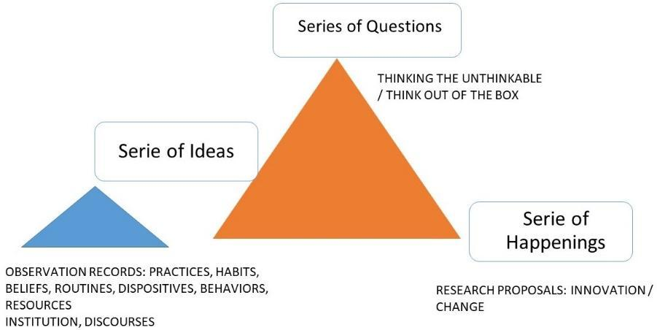

**Source**: own elaboration based on Deleuze (2005).

In the Series of Ideas, students are led to create awareness about the state of mind or collective ideas people usually have about an issue or problem. For example, Tik Tok is a social network used basically for entertainment. In the Series of Questions, students are encouraged to formulate questions that hesitate/doubt/suspect about the installed concepts in the Series of Ideas: What If Tik Tok is used for other purposes different from entertainment? What could happen if Tik Tok were used for English learning? The Series of Happening concrete what is formulated in the question by describing an innovative proposal: Teach Tok, a video-based social network for English learning.

In the WBL Didactical Design, IBL is implemented in the steps called "Inquire" and "Plan." In "inquire," teachers in training formulate problem questions based on the experience lived in the “Launch” step.

**Problem-based learning (PBL)**

It is significantly related to inquiry-based Learning; the difference is that in IBL, the problem can be given to students (Close inquiry), or students may make it up independently (open inquiry). In contrast, in PBL, the problem is close-inquiry type. The teacher gives the problem, and students search for information and get back to the problem to solve it Leal y León 2017, as cited in Arías *et al.,* (2019).

To the aims of the current study, it is worth noting the following features of PBL Luengo Caballero (2014 as cited in Arias et al., 2019): it is a student-centered methodology, problems are realistic and are the core component of instruction, students work collaboratively in small groups what implies commitment and autonomous learning, the teacher becomes a facilitator of knowledge construction, students develop critical thinking, problem management skills, and self-directed learning skills; finally, PBL can be used to teach any subject area. Several experiences incorporated PBL into technology, what is called ePBL. Arias and Martin (2015, cited by Arias et al., 2019) combined PBL with synchronous virtual classrooms (SVC) in higher education. The authors remark that the most meaningful fact in the experience is not the technology used but the methodology to develop it. This methodology is proposed in three basic actions: teaching planning, teacher management, and technical management tools. Among these tools, the authors mention: audio communication tools, direct instant messaging, user profile configuration, which can coexist in the virtual room, presence control, interactive whiteboard, monitoring and evaluation tools, and shared and remote desktop.

Regarding ELT, Othman and Shah (2013) investigated the effects of the PBL approach on students' language classes in course content and language development. They found benefits of PBL in the latter aspect, specifically in writing composition. Their manuscripts were richer regarding the group that did not intervene in terms of support and arguments.

Ansarian and Teoh (2018) assert that there have been many failed attempts to incorporate PBL into ELT. Implementing PBL in language classes is notably different from implementing it in other disciplines since, in an English classroom, language is both the means and the target of instruction. Teachers must be aware of students' content learning and language development simultaneously. This fact makes it necessary to design PBL models that fulfill these specific characteristics of the language classroom in terms of the particularities of students' cultures and backgrounds.

From these steps of the Problem-Based Language Learning model, the Web-Based Learning Didactical Design shares the idea of knowledge as a problem and as a collective construction through teamwork; however, problems are not created by the course teacher or the teachers in training, but they are the result of an initial activity that triggers interests and provoke the formulation of questions. On the other hand, problems are not inherent to a practical solution. They are ways of conceiving new dispositions of thinking and conceiving already established knowledge instead. It is understood that before going to a collective work to discuss the information searched, teachers in training need to process it individually. Reflection is also a common final step in both models. The teachers in training self-evaluate their performance, and in the case of the WBL Didactical Design, they also evaluate the different moments in the learning trajectory.

**Collaborative learning (CL)**

As with any other theoretical foundation analyzed in this section, CL results from knowledge construction through research from different human disciplines, especially psychology, sociology, and motivational theories. Moreover, collaboration is one of the XXI Century competencies, and "Personal, Social and Learning to Learn" is one of the lifelong learning competencies. According to the European Communities (2019), developing these competencies implies skills like learning and working collaboratively and autonomously to plan and strive with one's learning, assess and share it, find support when needed, and manage one's career and interactions. It also includes the development of attitudes like respecting the diversity of others, showing tolerance, expressing and understanding different points of view, and building confidence and empathy.

As can be seen, CL is more than a theory or a classroom strategy or activity; it is related to enhancing the human dimension. CL is frequently used instinctively to refer to Cooperative Learning or Peer Collaboration Learning. Smith and MacGregor (1992, cited by Barkley et al., 2014) provide a definition where CL is a general term that contains other approaches with the same idea of a group of students or students and teachers working mutually to comprehend a theme, get solutions to a problem or make a product.

Bruffee (1995, cited by Barkley et al., 2014) distinguishes between cooperative learning and collaborative learning based on the aims they pursue. The goal of cooperative learning is “to work together in harmony and mutual support to find the solution” (p.6). At the same time, CL seeks “to develop autonomous, articulate, thinking people, even if at times such a goal encourages dissent and competition that seems to undercut the ideals of cooperative learning” (p.6).

In the proposed didactical Design, CL plays a fundamental role in constructing knowledge from tacit to explicit and its final application. After making the interest groups based on the formulated questions, teachers in training search for information individually and publish the result in their Personal Learning Environments (PLE). The group members visit each other's PLE before the Share moment, where teachers in training work collaboratively to discuss the finding and prepare the team presentation for the whole group. That way, knowledge is approached individually, in teams, and then in the whole group. Feedback is given in the last two moments, and teachers in training are given the chances they need to make adjustments. Online team and group discussions are done by subdividing teachers by using a video conference platform that allows it. The Learning Management System (LMS) has space for "Guest Speakers" where foreign lecturers and learners are invited to share their experiences using technology for ELT.

**Task-based learning (TBL)**

From a Communicative Language Teaching (CLT) perspective, acquiring a language goes beyond understanding grammar or memorizing vocabulary. The primary purpose is to use the language for effective communication in natural settings. Grammar and vocabulary are sub-skills underneath the main transactional aim of managing skills. One of the well-known methodologies for CLT is Task-Based Learning and Teaching (TBLT), whose main idea is to learn through real-life activities or "learn by doing” (Laurillard, 2002; Ellis, 2003; Willis & Willis, 2009; cited by Blake, 2018, p. 67). Long *et al.,* (2019) define TBLT as:

The use of a syllabus whose content is a series, not of linguistic forms, but of pedagogic tasks sequenced in terms of increasing tasks, not linguistic, complexity, and lessons whose primary focus is communicative use of the L2 to complete those tasks. (p.501).

Ellis (2003, cited by Thomas & Reinderst, 2010) suggests six criteria features for TBLT: tasks contain a plan students need to follow, activities are focused on making meaning, they engage students in real-world, authentic language use, they are focused on language skills, students make use of cognitive skills to solve the tasks, tasks have a communication-based learning outcome. By the same token, Ellis (2009) says that to be considered a task, an activity must meet these criteria: focus on meaning, have a gap that students need to fulfill to accomplish the task, students need to rely on linguistic and non-linguistic sources the need to use, and have an outcome or a product to show as evidence of task achievement.

From a macro perspective, implementing TBLT Long (2015) starts with a needs analysis that provides input for teachers to design a syllabus that targets students' interests, likes, and necessities. With this syllabus design, teachers must develop task-based materials and plan a methodology to implement the tasks. Finally, the learning process is assessed in two ways. One is through the exit tasks according to the proposed learning outcome (in the case of ELT, it could be the progress students reach in language skills or subskill) and the course evaluation from a macro perspective.

For teachers' training in using ICTs for ELT, activities in the learning trajectory arise in the form of tasks. The first task comes from the construction of the question and the creation of interest groups. Teachers in training look for information to answer the set question(s) to share this knowledge with the class. The second task is the Application of constructed knowledge in the community, which demands thinking a "how," planning the execution, collecting the evidence, and sharing the experience with the class again. As most of the applications of digital tools for English teaching are related to its incorporation to enhance the development of language skills and subskills, TBLT is mainly applied in lesson planning that describes the preparation and build background activities in the pre-task stage, application of technology in the development of the task and final reflection of students about the use of the tool and self-evaluation performance in the post-task stage.

**Cultural and intercultural communicative competence (CIC)**

Being a proficient second or foreign language speaker is not only being language competent but also communicative and intercultural communicative competent.

Balboni (2006) defines language competence as generating validation or falsifying correctness. He refers to those grammar rules that make a statement to be accepted—for example, the order of words in a sentence. Communicative competence is at a higher level because it does not only include language competence but also sociolinguistic (social factors that influence language use), pragmalinguistics (strategies for realizing speech intentions and the linguistic items used to express these intentions), and extralinguistic grammar (non-verbal signs and clues), what allows comprehension, production and interaction in the target language. Intercultural communicative competence deals with managing at least two communicative competencies in two languages and cultures to allow interaction between the two.

For Byram *et al.,* (2002), developing intercultural competence in language teaching aims at preparing students to interact with people from other latitudes, to make them aware that there are other cultures whose individuals have different values, behaviors, and ways of thinking, and to make students realize that such interaction is an edifying experience.

Deardorff (2006) proposes a model for developing intercultural competence based on five elements: Attitudes (respect, openness, and curiosity); knowledge (cultural self-awareness, culture-specific knowledge, deep cultural knowledge, and sociolinguistic awareness); skills (observing, listening, evaluating, interpreting, and relating); internal outcomes (attitudes, knowledge, and skills transformed into flexibility, adaptability, and empathy); and external outcomes, (behavior and communication skills that are the product of a person's attitudes, knowledge, skills and internal outcomes).

This question arises: How can cultural and intercultural competence be developed in a foreign language environment? The answer seems obvious: by exposing students to native, native-like speakers or speakers of English from other languages either personally or through mediated technology. In the proposed WBL Didactical Design, the cultural and intercultural development is a transversal component that is evident in the "launch" experience by the use of authentic multimedia materials and in the "search" where teachers in training approach written and audio resources; besides, the LMS platform contains a "Guest Speaker" section and links to online dictionaries.

**Community-based pedagogies (CBP)**

Linking classroom knowledge to communities is something that has been introduced previously. Freire (2005); Giroux (1992); and Kumaravadivelu (2003) made sense of pedagogy by developing critical thinking in students about their home communities. Freire (2005) proposes a problem-posing education where humans critically perceive the world as a reality of transformation. Giroux (1992) claims a border pedagogy that equips students to think about their communities beyond the limits of reigning discourses through multiple narratives in critical reading and denouncing writing practices. Kumaravadivelu (2003) criticizes traditional classroom English Teaching methods by proposing a post-method pedagogy founded on three parameters: particularity, practicality, and possibility. The first parameter posits that any language pedagogy must be sensitive to a specific sociocultural context; the second involves a teacher-generated theory of practice, and the third pursues identity formation and social transformation through continual participants' quest.

Committed to the purposes mentioned above, a CBP teacher is a social activist that can involve the knowledge, beliefs, constructs, and perceptions of local communities in the teaching practice Lastra *et al.,* (2018) and enacts those knowledge traditions to make meaningful connections with children and their families (Murrell, 2001, cited by Sharkey et al., 2016). Developing CBP projects implies that teachers become sensitive to the community where they work, being able to transform the posed curricula into a meaningful curriculum by knowing and integrating the sociocultural and economic realities of his/her students.

CBP is evidenced in the WBDD in the plan, application, and reflection stages. Teachers in training are encouraged to think about problem questions that link the acquired content and knowledge with their context by applying the technological content knowledge to solve a language problem, a language learning problem, or even a social problem they encounter in their classrooms or communities. For example, one of the teachers in training may realize that students in his/her classroom may lack oral comprehension skills. He/she may formulate a unit project to use song lyrics to train them on listening for general understanding or listening for detailed information. Although the emphasis could be on understanding, students in his/her classroom may also participate in karaoke activities to improve their pronunciation. The teacher in training may also incorporate different digital resources to tackle problems his/her students may have with reading and writing: make an eBook that incorporates multimedia, social network, and animated tools to narrate family stories, write about their neighborhoods, their home towns or their expectation for future careers. Teachers in training are encouraged to listen to their students, who are the ones that know their communities better. Training teachers formulate problem questions and plan community interventions based on the manifested needs.

**Learning sequence**

**Launch (online)**

Learning is a Happening in the way Deleuze defines it in one of his axioms: “The event is of a different regime than the actions and passions of the body, even if it results from them” (Badiou, 2007, p. 38). In this way, an event is different from what happens every day, something out of the ordinary and familiar: a sunset that makes us turn our eyes to the Sun, a movie plot that occupies our minds after the function ends.

The Launch must be an activity that affects students’ minds and senses from the first moment of the teaching act. This demands that the teacher be tuned with students' interests, likes, and preferences and find creative ways of connecting all this with the contents, the aims, and other curriculum components. To teach a lesson about past habits, the teachers in training may use photos from their albums to tell the class what they used to do when they were children or prepare a PowerPoint presentation with real pictures of activities they usually do in a day.

In this first moment, besides triggering interest, the teacher builds background for the new learning. It means helping their students connect what they already know with what they will learn. Vogt and Echeverria (2008) explicitly mention three forms of building background. The first links concepts to students' experiences (family, neighborhood, community in general), the second links past learning to new concepts, and the third emphasizes key vocabulary (write, repeat, highlight). The class about past habits may continue with students trying to say similar sentences like the ones introduced by the teacher to tell the class what they used to do when younger or when they lived in a different town or neighborhood. The teacher needs to highlight new expressions and new vocabulary so that students grasp their meaning to be used later in the lesson.

**Inquire (online)**

In the traditional school, questions are part of a test, are a strategy to confirm students’ learning, and are a kind of control over the knowledge that the teacher owns. Questions are part of a dialectical thought that seeks truths. These "truths" are in the books or are part of the teacher's speech. For Deleuze (2005) knowledge does not exist but is continuously constructed through questions. As it was shown before in Figure 3, when the installed knowledge or believed truth is quizzed utilizing problem questions, it is possible to make the Happening emerge. In that way, the Happening is that idea, that proposal of a different thought that allows us to see what we fail at or deny to see; that is, thinking what was unthinkable. In this regard, Velásquez (1995) concludes that when thinking is guided through questions, one enters into a zone whose aim is not to look for solutions but a space for experimentation that enables innovation in social living.

In this way, “Inquire” is the moment in the learning trajectory when the teacher on training poses questions provoked by the event in the “Launch.” They are guided to write a list of questions and transform them into problem questions through the guide of the Logic of Sense. These questions must include a proposal and the "What if..." type or "What could happen if."

**Search (offline)**

After defining the individual tasks, each team member does an individual search. Teachers in training may need the course teacher's guidance on this concern by training them on how to do trustful and reliable quests by using well-known web browsers like Google or Bing, or Yahoo, or more academic sites like Google Scholar, Web of Science, Springer or any other databases. Once teachers in training refine the search and have the information ready, they publish it in their PLEs and send alerts to the team members to start the virtual visits. Teachers in training may include comments about the posted information, and they may also suggest corrective feedback for language use. Every teacher in the course needs to visit the PLEs and write a summary of the main ideas contributing to elucidate the problem that was turned into questions.

Teachers in training hold an online meeting to plan the presentation of findings to each question. They may prepare a short video presentation of a guided tutorial to be shown to the whole class. For the application of resources from the English Teaching Digital Taxonomy (Figure 1), they may present, for example, a tutorial to illustrate what "Tik Tok" is, the tools it has to edit videos and make suggestions on its use to develop a language sub-skill or skill.

**Share (online)**

In an online session, teams present their findings to the whole group. Each team must remember the problem questions to make connections with the new information. After each presentation, the group has time to clarify possible doubts or debates based on the related problem questions and information searched. After all the teams present the information, teachers in training self-assess and assess each other to decide if the information is clear enough to give hints about the problems. The aspects in the checklist or the rubric gave before the search stage is used to make informed decisions. If the class decides that the team needs to continue the search, the team is given time to accomplish the aim of the activity. If necessary, team tutorials with the course teacher are programmed.

**Plan (online)**

Teachers in training gather again to find concrete strategies to impact the community or to put into practice the constructed learning. The course teacher affords a guide for students to organize the planning with the following information: problem-question(s), description of the context and population, objectives, tasks, resources, expected results, and achieved results (see annex I)

In the case of the teachers' training course, student teachers may incorporate digital tools into the development of language skills and subskills.

**Apply (offline)**

Teams work to execute the plan with the constant support and assistance of the course teacher. Teachers in training need to collect evidence of the steps in the plan to consolidate the data for the final oral report. Teams may hold video conferences with the course teacher to receive feedback and recommendations whenever required.

Once the implementation is done, teachers in training look for a creative manner to present the results to the whole class. The course teacher needs to inform the time each team has for the presentation and the assessment criteria.

**Share (online)**

The course teacher may organize a school event, like an online project fair, to present the results of the learning projects. Teams take turns to present the results of their application. In the end, there should be time for questions, comments, and debate with the participation of the community and guest experts in the themes.

**Reflect (offline-online)**

Teachers in training self-reflect on their participation and collaboration in each of the learning moments based on a checklist or rubric (See annex II). They may write a reflection paper that can be taken as a learning outcome of the unit/module/course. This is another chance to provide corrective feedback about writing abilities.

In an online session, teachers in training assess the development of the learning trajectory and may share their personal reflections. They also answer an assessment survey of the didactical Design and suggest improvements.

**CONCLUSIONS**

The conducted literature review allowed us to conceive the WBLDD as a student-centered methodology that defines a trajectory with clear stages founded on existing pedagogical theories and intends to develop teachers-learners' self-regulated strategies using online instruction and offline independent work. Integrating technological content into pedagogical content is done through reflection moments that create awareness of substitution, augmentation, modification, and redefinition processes. The construction of knowledge happens from the elaboration of explicit knowledge to tacit knowledge through individual and collaborative work and the use of PLE as a facilitator of students’ self-regulated learning.

About existing educational theories, the construction of the learning design takes into account the integration of technological, pedagogical, and content knowledge, emphasizing the practical application of the theory through the use of didactical strategies that involve the formulation of problem questions, teamwork in collaborative learning, the actual impact in the learning community using the formulation of Community-Based projects and the acquisition of the language through the exposure to the target language culture. The primary aim of the Learning Design is to affect teachers' digital competence in the adoption, adaptation, appropriation, and innovation of technology by following the DigCompEdu framework Cabero-Almenara and Palacios-Rodríguez (2020) as a reference. Teachers in training are expected to feed the proposed English Teaching Digital Taxonomy as they gain experience applying acquired competence in their classrooms.

The effectiveness of the WBLD depends on the result of the implementation phase, which is done through a Course in Digital Competence for English teachers and organized according to their Digital Competence. For the Didactical Design, there are no pre-conceived curriculums with lists of topics and activities to be accomplished. The construction of the course depends on the real needs of teachers in the use of digital tools for the development of language skills and subskills.

Understanding that a Pedagogical Model for E-learning is composed of a Pedagogical architecture and a strategy of application of that PA (Behar, 2011), the present proposal results innovative in the sense that there are no didactical designs or pedagogical models to train teachers in the integration of ICT into ELT, with precise learning moments and founded on solid theories

**CONFLICT OF INTEREST DECLARATION**

The authors declare that during the execution of this work or the preparation of the article, no personal or external interests have influenced their actions, including misconduct and values different from those typically and ethically associated with research. The Web-Based Didactic Design is licensed under Safe Creative with Certificate Identifier: 2302033338647-7MSFCP, wherein 90% of the Intellectual Property Rights are assigned to the University of Tolima, represented by Gonzalo Camacho Vásquez, and 10% of these rights are assigned to the University of Jaén, represented by Elena María Díaz-Pareja and Juana María Ortega-Tudela.

**BIBLIOGRAPHICAL REFERENCES**

Acar, O. A. & Tuncdogan, A. (2018). Using the inquiry-based learning approach to enhance student innovativeness: a conceptual model. *Teaching in Higher Education*. DOI: 10.1080/13562517.2018.1516636

Ansarian, L. & Teoh, M. (2018). *Problem-based Language Learning and Teaching: An Innovative Approach to Learn a New Language*. Singapore: Springer. https://books.google.com.co/books?hl=es&lr=&id=UfxlDwAAQBAJ&oi=fnd&pg=PR7&dq=Problem-based+Language+Learning+and+Teaching:+An+Innovative+Approach+to+Learn+a+New+Language.&ots=WRs47lnYZb&sig=fwBx9khAyvShqNEhGufTvHOhTcY&redir_esc=y#v=onepage&q=Problem-based%20Language%20Learning%20and%20Teaching%3A%20An%20Innovative%20Approach%20to%20Learn%20a%20New%20Language.&f=false

Arías, J., Martín, R., Gutiérrez-Esteban, P., Delicado, G., Cubo, S., Alonso-Díaz, L. & Yuste, R. (2019). Synchronous Virtual Classrooms in Problem-Based Learning to Mentor and Monitor Students in Higher Education. In *Universities in the Networked Society* (pp. 133-154). Springer, Cham. https://link.springer.com/chapter/10.1007/978-3-030-05026-9_8

Badiou, A. (2007). The Event in Deleuze. *Parrhesia. A Journal of Critical Philosophy*. No. 2. <http://parrhesiajournal.org/parrhesia02/parrhesia02_badiou02.pdf>

Balboni, P. (2006). Intercultural Communicative Competence: A Model. *Documents in Language Teaching Methodology.* Perugia: Guerra Edizioni.

Barkley, E. F., Cross, K. P. & Major, C. H. (2014). *Collaborative learning techniques: A handbook for college faculty*. John Wiley & Sons.

Behar, P. (2011). Constructing Pedagogical Models For E-learning. International Journal of Advanced Corporate Learning (iJAC), 4(3), 16–22. Kassel University Press GmbH. https://www.learntechlib.org/p/45571/.

Blake, R. J. (2018). La ELAO en el marco del enfoque por tareas. *CÍRCULO de Linguística Aplicada a la Comunicación*, *76*, 67. <https://revistas.ucm.es/index.php/CLAC/article/view/62498/4564456548718>

Borgdorff, H. (2006). The debate on research in the arts. Available at: [www.ips.gu.se/](http://www.ips.gu.se/) digitalAssets/1322/1322713_the_debate_on_research_in_the_arts.pdf. 3, 4

Branch R. M. (2009). *Instructional Design: The Addie approach*. Springer.

Byram, M., Gribkova, B. & Starkey, H. (2002). *Developing the intercultural dimension in language teaching: A practical introduction for teachers*. Language Policy Division, Directorate of School, Out-of-School and Higher Education, Council of Europe.

Cabero-Almenara, J. y Palacios-Rodríguez, A. (2020). Marco Europeo de Competencia Digital Docente «DigCompEdu». Traducción y adaptación del cuestionario «DigCompEdu Check-In». *Edmetic*, *9*(1), 213-234. https://www.uco.es/ucopress/ojs/index.php/edmetic/article/view/12462/11154

Camacho, G. (2017). La lógica del sentido incorporada a la noción de investigación como una orientación para el aprendizaje: dos experiencias en el aula. *GIST–Education and Learning Research Journal*, (14), 88-106. <https://latinjournal.org/index.php/gist/article/view/406/350>

Camacho-Vásquez, G., Díaz E. & Ortega J. (2023). Pedagogical Models in Teachers’ Education on the Use of Technology for English Teaching: A Systematic Review. Revista Zona Próxima Universidad del Norte. Manuscript submitted for publication.

Cong-Lem, N. (2018). Web-based language learning (WBLL) for enhancing L2 speaking performance: A review. *Advances in Language and Literary Studies*, *9*(4), 143–152. doi:https//doi.org/10.7575/aiac.alls.v.9n.4p.143

Deardorff, D. K. (2006). Identification and Assessment of Intercultural Competence as a Student Outcome of Internationalization. *Journal of Studies in International Education*, *10*(3), 241–266. <https://doi.org/10.1177/1028315306287002>.

Deleuze, G. (2005). Quinta Serie del Sentido:“Novena Serie de lo Problemático”: “Vigesimoprimera Serie: del Acontecimiento. *La Lógica del Sentido*, 50-72.

Dohn, N., & Hansen, J. J. (2014, July 7). Is learning designs something you think, do, live with, react to, or conceptualize with? Paper presented at the Designs for Learning Conference, Stockholm, Sweden.

Ellis, R. (2003). *Task-based language teaching and learning*. Oxford: Oxford University Press.

Ellis, R. (2009). Task-based language teaching: Sorting out the misunderstandings. *International Journal of Applied Linguistics*, pp. *19*, 221–246.

Esteve F., Castañeda L. y Adell, J. (2018). Un Modelo Holístico de Competencia Docente para el Mundo Digital. *Revista Interuniversitaria de Formación del Profesorado*, 2018, 32.1

European Communities. (2019). *Key competencies for lifelong learning*, Publications Office. <https://data.europa.eu/doi/10.2766/569540>

Freire, P. (2005). *Pedagogy of the Oppressed.* 30th Anniversary Edition. New York: Continuum.

Giraldo Cadavid, D. A., & Fernández García, D. A. (2023). Aprendizajes derivados de la implementación de un dispositivo pedagógico en condiciones de enseñanza remota por Covid-19. *Praxis*, *19*(1). https://doi.org/10.21676/23897856.4611

Giroux, H. A. (1992). *Border crossings: cultural workers and the politics of education*. New York; London: Routledge.

Godin, D. & Zahedi, M. (2014). Aspects of Research through Design: A Literature Review, in Lim, Y., Niedderer, K., Redström, J., Stolterman, E. and Valtonen, A. (eds.), Design's Big Debates - DRS International Conference 2014, 16-19 June, Umeå, Sweden. <https://dl.designresearchsociety.org/drs-conferencepapers/drs2014/researchpapers/85>

Kalaian, S. A. (2017). Distance and Online Learning. In *Handbook of Research on Instructional Systems and Educational Technology* (pp. 23-36). IGI Global.

Kara, S. (2021). An investigation of visual arts teachers’ attitudes towards distance education in the time of COVID-19. *International Journal on Social and Education Sciences* (IJonSES), 3(3), 576–588. <https://doi.org/10.46328/ijonses.246>

Krippendorff, K. (2007). Design research, an oxymoron? In R. Michel (Ed.), Design research now: Essays and selected projects (pp. 67-80). Zürich

Kumaravadivelu B. (2003). *Beyond Methods: Macro strategies for language teaching*. Yale University Press. https://books.google.com.co/books?hl=es&lr=&id=zFUvFP6e4iMC&oi=fnd&pg=PP7&dq=Beyond+Methods:macrostrategies+for+language+teaching&ots=xlXgvNpAHE&sig=qtAPfzuD3p2xgqQU_-NcUM3vhNU&redir_esc=y#v=onepage&q=Beyond%20Methods%3Amacrostrategies%20for%20language%20teaching&f=false

Lastra, S., Durán, N. & Acosta, D. (2018). Community-based pedagogy is an eye–opening for pre-service teachers' initial connections with the school curriculum. *Colombian Applied Linguistics Journal*, 20(2), pp. 209-229.

Long, M. H. (2015). *Second language acquisition and task-based language teaching*. West Sussex, UK: Wiley Blackwell.

Long, M., Lee, Y. & Kobayashi, K. H. (2019). Task-Based Language Learning. *The Cambridge Handbook of Language Learning* (Cambridge Handbooks in Language and Linguistics). Cambridge: Cambridge University Press. doi:10.1017/9781108333603

Mishra, P. & Koehler, M. J. (2006). Technological pedagogical content knowledge: A framework for teacher knowledge. *Teachers College Record,* 108(6), 1017–1054.

Nonaka, I. & Takeuchi, H. (1995). *The Knowledge-Creating Company: How Japanese Companies Create the Dynamics of Innovation*. Oxford University Press, New York.

Othman, N. & Shah, M. (2013). Problem-Based Learning in the English Language Classroom. *English Language Teaching*. 6. 10.5539/elt.v6n3p125. https://eric.ed.gov/?id=EJ1076845

Pedaste, M., Mäeots, M., Siiman, L.A., de Jong, T., Van Riesen, S.A.N., Kamp, E.T., Manoli, C.C., Zacharia, Z. C. & Tsourlidaki, E. (2015). Phases of inquiry-based learning: Definitions and the inquiry cycle. *Educational Research Review, 14*(1), 47-61. Elsevier Ltd. Retrieved October 14, 2022, from <https://www.learntechlib.org/p/197430/>.

Pikhart, M. (2018). Technology-enhanced learning experience in intercultural business communication course: a case study. In *International Symposium on Emerging Technologies for Education* (pp. 41–45). Springer, Cham. <https://doi.org/10.1007/978-3-030-03580-8_5>

Puentedura, R. (2013). *SAMR: Getting to transformation*. http://www.hippasus.com/rrpweblog/archives/2013/04/16/SAMRGettingToTransformation.pdf

Puentedura, R. (2014). *Learning, technology, and the SAMR model: Goals, processes, and practice.* <http://www.hippasus.com/rrpweblog/archives/2014/06/29/LearningTechnologySAMRModel.pdf>.

Salem, A. A. M. (2019). Learning in a sheltered online scaffolding environment (SOSE). *Educ Inf Technol* 24, 2503–2521.

Sharkey, J., Clavijo Olarte, A. & Ramirez, L. M. (2016). Developing a deeper understanding of community-based pedagogies with teachers: Learning with and from teachers in Colombia. *Journal of Teacher Education*, *67*(4), 306-319.

Suhendi, A. (2018). Constructivist learning theory: The contribution to foreign language learning and teaching. *KnE Social Sciences*, pp. 87–95. <https://knepublishing.com/index.php/KnE-Social/article/view/1921/4298>

Thomas, M. & Reinders, H. (2010). Deconstructing tasks and technology. *Task-based language learning and teaching with technology*, 1-16. <https://books.google.com.co/books?hl=es&lr=&id=QGkzsqQ4HaoC&oi=fnd&pg=PA1&dq=Deconstructing+Tasks+and+Technology.+Task-Based+Language+Learning+and+Teaching+with+Technology.&ots=nnclQn75Jg&sig=tZSoT3nx6YP77RximN3KqqUb1KY&redir_esc=y#v=onepage&q=Deconstructing%20Tasks%20and%20Technology.%20Task-Based%20Language%20Learning%20and%20Teaching%20with%20Technology.&f=false>

Velásquez, R. E. (1995). *Preguntar la escuela. Unidad Coordinadora de Prevención Integral*. Serie Prevenir es Construir Futuro. Alcaldía Mayor de Bogotá

Vogt, M. & Echevarria, J. (2008). *99 ideas and activities for teaching English learners with the SIOP model*. Boston: Pearson Allyn and Bacon.

Willis, D. & Willis, J. (2009). "Task-based language teaching: Some questions and answers." *Language Teacher* 33, 3, 3–8.

Zheng, R. (2008). Understanding the underlying constructs of Webquests. In *Handbook of research on instructional systems and technology* (pp. 752–767). IGI Global.

**ANNEXES**

**ANNEX I.** Guide for the planning

**Problem question(s):** How respectful of sexual differences and sexual inclinations is our community?

**Context:** Students, parents, and teachers of 9th grade, Colegio La Sagrada Familia, Ibague.

**Objectives:**

To find out how respectful of sexual differences our school community is.

To put on a campaign to foster sexual differences’ respect

**Tasks:**

1. Administer an online test to the target population.
2. Analyze and graph the results.
3. Organize a campaign to foster sexual differences and respect.
4. Put on the campaign and take evidence.

**Resources:**

1. Sexual differences’ test in Google Forms.
2. Guest speaker for talks online, support from the school counselor.
3. Workshop with parents.
4. Survey to know the effects of the campaign.

**Time:** 3 weeks.

**Expected results:**

Students, teachers, and parents will know how respectful they are towards sexual differences and in which area to work for better sensibilization.

Students, teachers, and parents will know the importance of respecting sexual differences and sexual rights.

**ANNEX II.** Self-assessment form.

|  |  |  |  |  |  |  |  |
| --- | --- | --- | --- | --- | --- | --- | --- |
| **Learning moment** | **Performance statement** | **Weight (1-5)** | | | | | **Comments** |
| **1** | **2** | **3** | **4** | **5** |
| Launch | I took part in the launch activity by making background connections. |  |  |  |  |  |  |
| Inquire | I was able to formulate problem questions. |  |  |  |  |  |  |
| I participated in an interest group. |
| I helped to polish problem questions. |  |  |  |  |  |  |
| Search | I made my personal inquiry for the assigned question(s). |  |  |  |  |  |  |
| I posted the results in my PLE. |
| I visited my teammate's PLE, read the information, and made comments (when it applied). |
| Share | I participated actively in the sharing session of searched results. |  |  |  |  |  |  |
| Plan | I contributed with own ideas to make a plan of application. |  |  |  |  |  |  |
| Apply | I carried out all my assigned tasks for the “Apply” moment. |  |  |  |  |  |  |
| Share | I participated actively in the sharing session of application results. |  |  |  |  |  |  |
| Reflect | I did the self-reflection and course reflection. |  |  |  |  |  |  |
|  | Total |  | | | | |  |

Final comments: _________________________________________________________________________________________________________________________________________________________________________________________________________________________________________________________

1. Magister Pontificia Universidad Javeriana, Bogotá, Colombia. Docente Asociado Universidad del Tolima. Estudiante Doctorado en Innovación Didáctica y Formación de Profesorado, Universidad de Jaén, Jaén, España. Correo Electrónico: gcv00005@red.ujaen.es. ORCID ID: 0000-0002-3207-6689
2. Ph.D. Universidad de Jaén, Jaén, España. Profesora Titular Universidad de Jaén (España) Correo Electrónico: emdiaz@ujaen.es. ORCID ID: 0000-0001-5255-2761.
3. Ph.D. Universidad de Jaén, Jaén, España. Profesora Titular Universidad de Jaén (España) Correo Electrónico: jmortega@ujaen.es. ORCID ID: 0000-0003-3649-3524.